FamilySearch Catalog icons

Below is a list of the icons found in the current version of the FamilySearch catalog to indicate the status of options available for viewing the film.

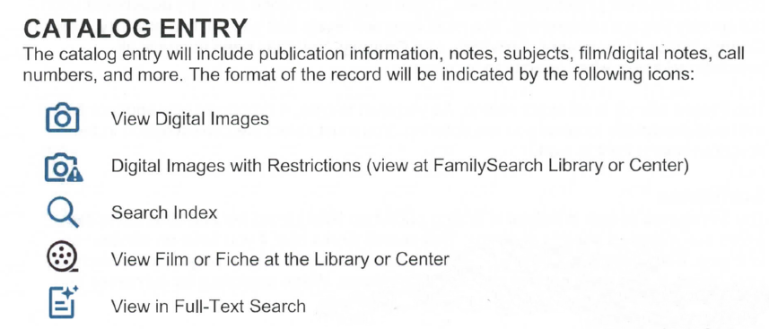

Source – FamilySearch

DF: 6/7/2025 10:08 AM

