The Phillimore Atlas and Index of Parish Registers
by Cecil R. Humphery-Smith
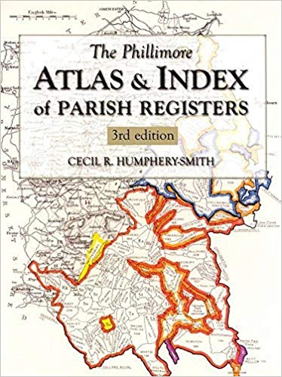
(Third Edition)

This is a reference volume by Cecil R. Humphery-Smith providing information about the parishes in each county in England. The book also includes information about counties in Wales and Scotland, although the main focus of the content is the counties of England. The book is divided in two sections: The Atlas and The Index
The Atlas includes individual maps of each county in England – both a topographical map, and a detailed map showing the parish boundaries within the county. The black and white topographical maps include a list of the hundreds. The topo maps are very busy, and you will likely need a magnifying glass to make effective use of them. The county maps in color include the boundaries of pre-1832 parishes and the boundaries of other jurisdictions such as the ecclesiastical and probate jurisdictions.
Here is an example of the map for Hertfordshire.
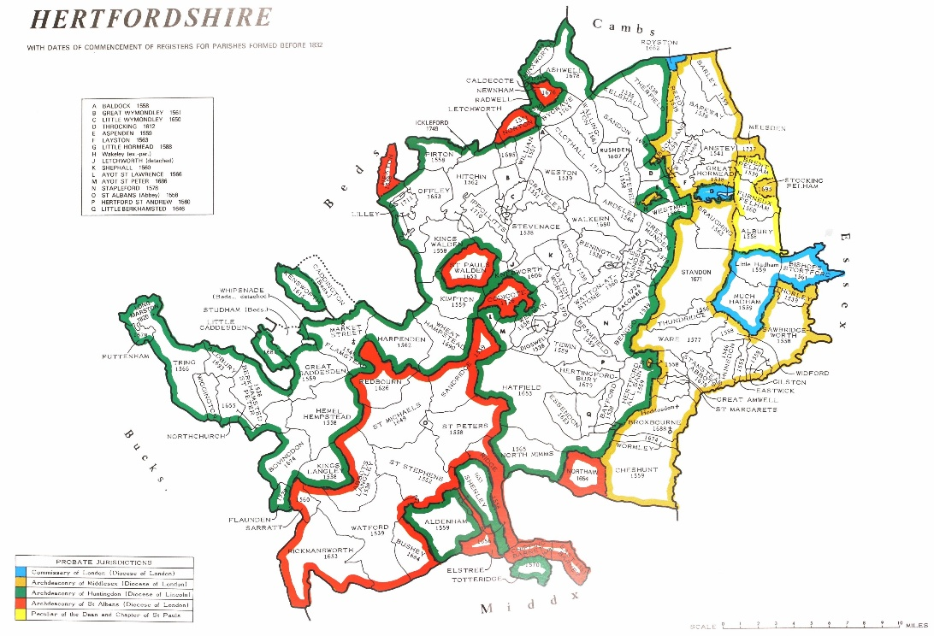

The Index part of the book includes details about the parishes. That includes a full alphabetical list of all the parishes in each county and the dates and other details about the parish records. Further reference information on that is provided overleaf.

The Phillimore Atlas and Index of Parish Registers

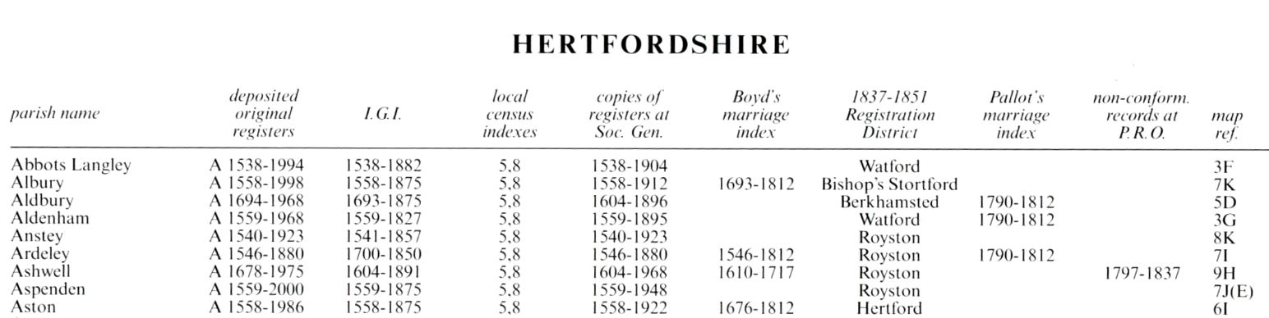

This handout is intended to serve as a handy reference guide to the Phillimore Atlas in understanding the column headings on the county pages in The Index section of the book. These headings provide details about the records for parishes within each county. Below is a brief description for each heading.
Parsh name: the name of each parish in the county arranged in alphabetical order.
Deposited original registers: earliest dates for which baptism, marriage and burial records exist for that parish The A-B-C letter preceding the dates refers to the location of the depository where the original registers were deposited and are described in notes at the end of the county section.
I.G.I.: indicates whether parish records are included in other indexes, such as those historically created by the IGI (International Genealogical Index).
Local census indexes: information related to census indexes for each parish, aiding the use of census records with parish registers. The numbers 5, 7, 8, 9 refer to the census year as follows: 5-1851; 7-1871; 8-1881; 9-1891. (Note: the 1901 index was not available when work began on the Third Edition, which also predated public access to the 1911 and 1921 Censuses.)
Copies of registers at Soc. Gen.: years for which there is a copy of the registers for that parish at the Society of Genealogists in London.
Boyd’s marriage index: range of years for which there are records in that parish included in Boyd’s marriage Index.
1837-1851 Registration District: name of the civil registration district in which that parish is located.
Pallot’s marriage index: range of years for which there are records in that parish included in Pallot’s marriage Index.
Non-conform. records at P.R.O.: range of years for which the Public Records Office holds non-conformist registers/records for that parish.
Map ref.: the grid reference to the county map found in The Atlas section of the book for the location of the parish.

It is also advisable to see the additional notes in the Editor’s Introduction, vii-xiii, which includes extra details.

Prepared by David Flint davidflintgenealogy@gmail.com 7/24/2025 8:03 AM

