WDYTYA Magazine -- Online Tutorial Articles

The London Gazette by Paul Blake
https://www.whodoyouthinkyouaremagazine.com/tutorials/london-gazette
The London Gazette: What is it, how can you get a copy and how is it used in family history?
First founded in 1665, The London Gazette is the UK's official public record. Discover how you can research history for free on The London Gazette's website.
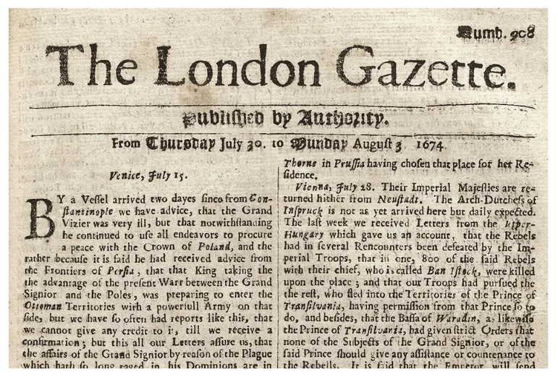

Debtors Prison by Paul Blake
https://www.whodoyouthinkyouaremagazine.com/feature/the-fascinating-history-of-debtors-prisons
What is a debtors' prison?
People who fell into debt in the past could find themselves in prison until the debt was paid.
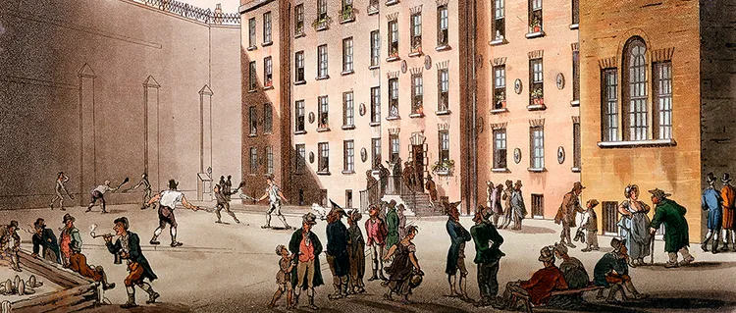

DF: 7/21/2025 10:42 AM

